# Report 6

This report includes updates and progress report for Task 2.

## Scope

|  |  |  |
| --- | --- | --- |
| **Tasks:** | **Task Goal/ Desired outcome** | **Progress** |
| Task 1 | **PCR data management**  Extracting the data in (.csv) from original PCR results file(.eds) | Quant-Studio 5: Completed |
| Quant-Studio 7: Completed |
| Next instrument: QS-7500  I stopped for now |
| Task 2 | **GS-Call data work-flow**  *Goal:*  This task aims to put the PCR result data into a proper format for further analysis in GS-Call software.  *Desired outcome:*  The application should open up in the web browser and take the user input info, then generate a specific formatted (.csv) file containing the information of samples/targets to be imported on the PCR machine by the user. | 1. Coding 95% |
| 1. Deploying the app   From next week |
| 1. Developing a data base in SQL and connecting that to the app |
| 1. Deploying the app with SQL database |
| :D more challenges to come |

## Task 2 (*GS-Call data flow)* progress:

We are working on GSL_Experiment_Setup web application to generate the layout information for PCR experiment.

***What the algorithm does:***

The algorithm works based on the data (panels: targets vs filters) for each “kit/product” and the given samples names list/number. Then, assuming a predefined layout of master mixes/ sample location through 384/96 well plate (according to Figure 2 & 3), generates the csv file including the info for all wells (a sample is attached to the email).

***GSL Experiment Setup workflow:***

1. Basic use:

The application allows the user to choose the plate size, select the kits they want to test, and the instrument they are going to run their experiment. Then, the selected kits are labeled (A, B, C, …) and will be shown in the right-hand side panel for them to check and allocate the kits in interactive plate map that is shown (Figure 1). For example as it is illustrated in figure 1 user chose 2 kits (RP003) and (RP007) which are labeled as A and B and allocated in the plate map.

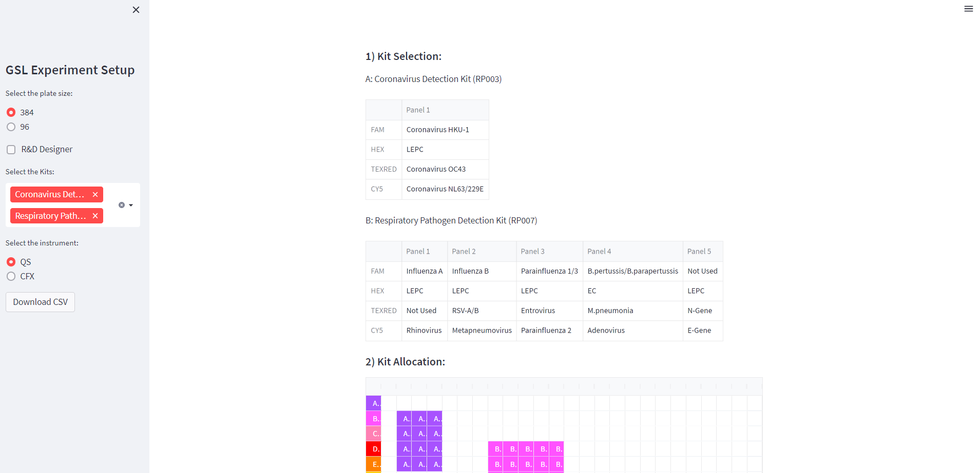

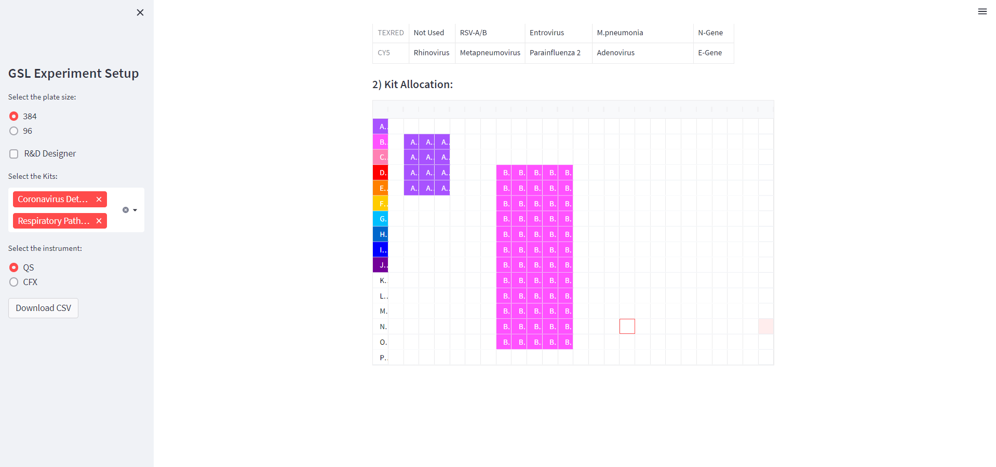

Figure 1: GSL Experiment Setup. With the sidebar user has the option to choose the plate size 96/384, and instruments QS/CFX. The app runs in 2 simple steps: 1) Kit Selection, and 2) an interactive platemap to allocate the kits within the plate. And download the import file (csv).

1. *R&D use:

A new feature has been considered for R&D use named “Designer” if the feature is selected from the side bar an interactive fields and table will open up in the right-hand side panel. The user has the freedom to define the kit name and select how many panels they like to have and enter their desired target names. The kit will be labeled as shown in figure 2 (label C) and will be added to the list of the available kits so that the user can allocate the new kit as well.

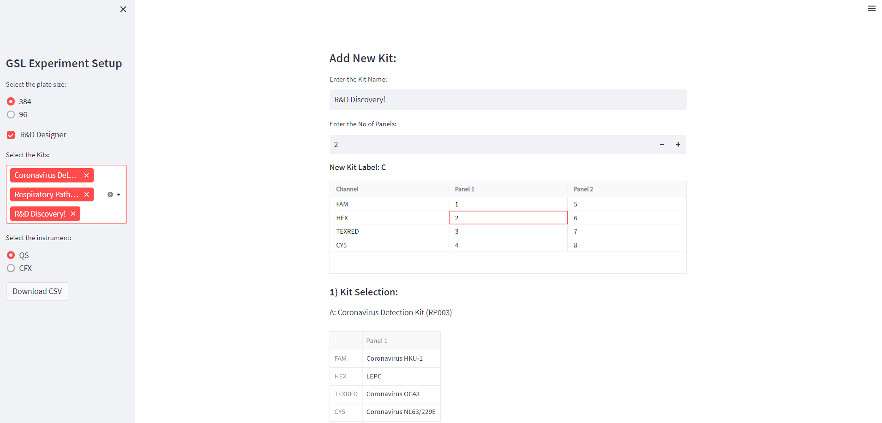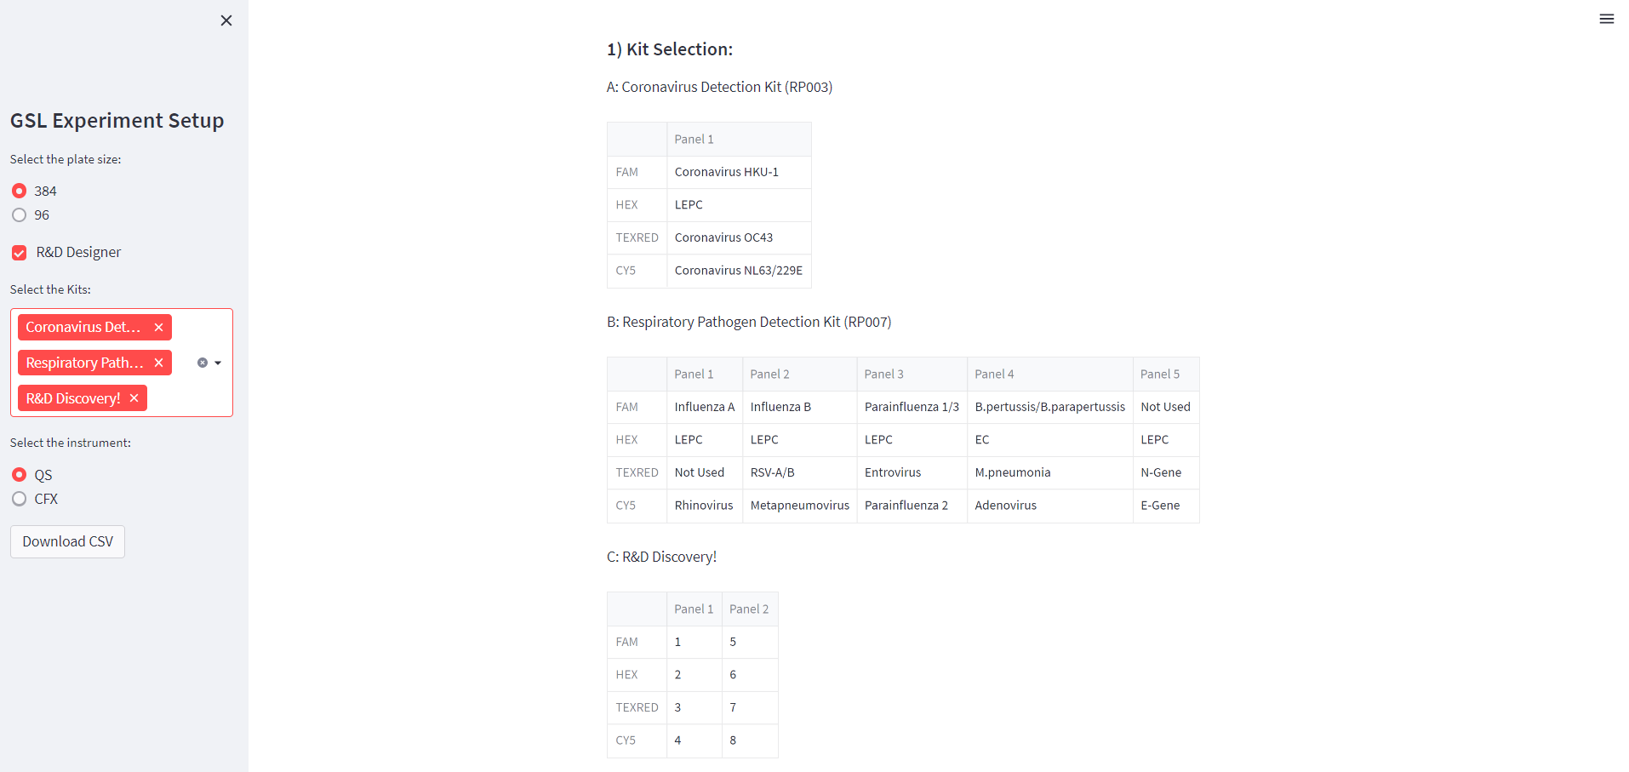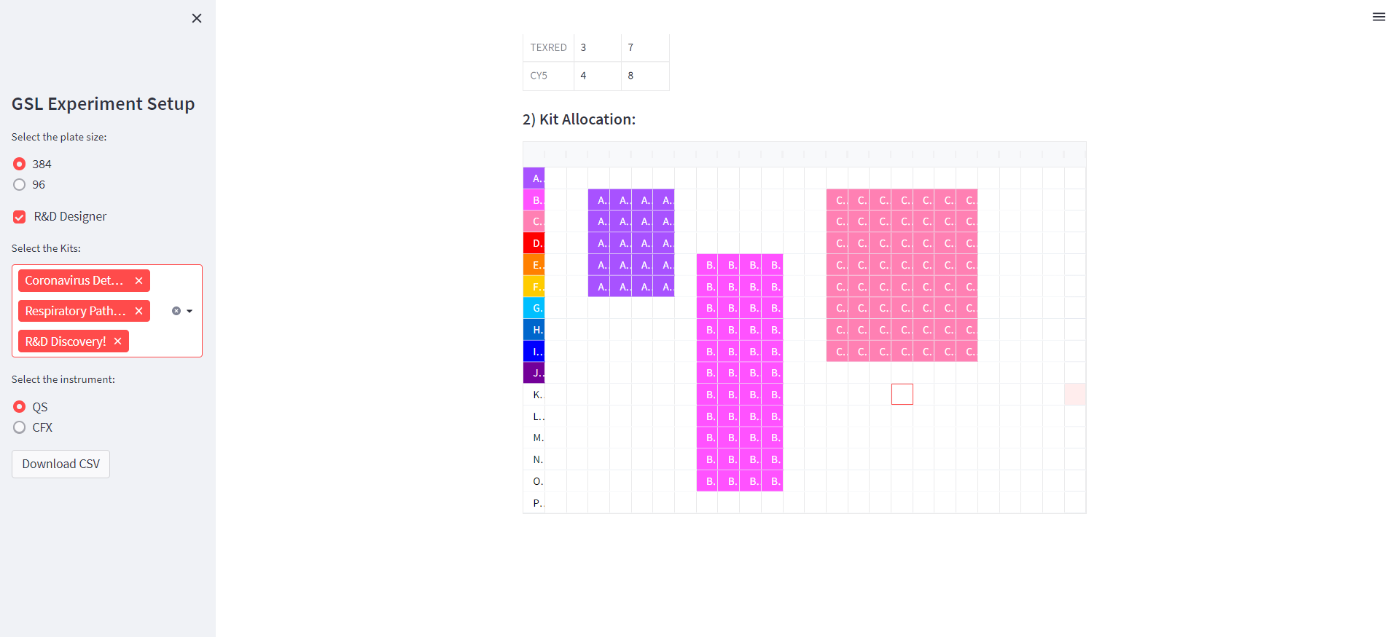

Figure 2. GSL Experiment Setup. R&D use “Designer” feature.

1. Results:

Once the setup and allocation are completed, the user can download the csv importfile.

*Please notice that once the user is allocating the kits they don’t need to be worried about the exact number of wells (vertically), the program will remove the excess rows that the complete kit panels cannot be assigned.

*At the moment the samples names are automatically assigned. For example for Kit A: (Negative control, 2A, 3A, …NA, Positive Control), Kit B (Negative control, 2B, 3B, …NB, Positive Control).

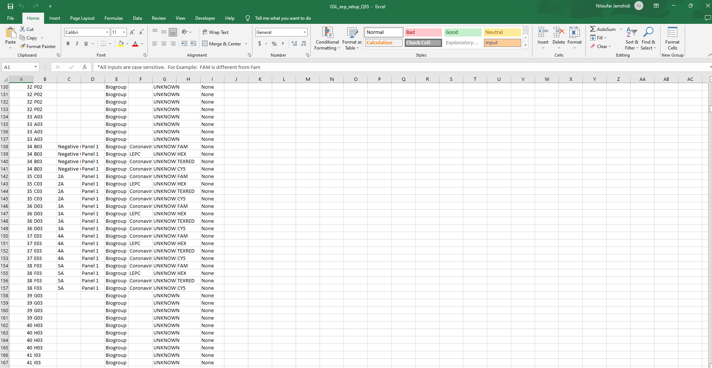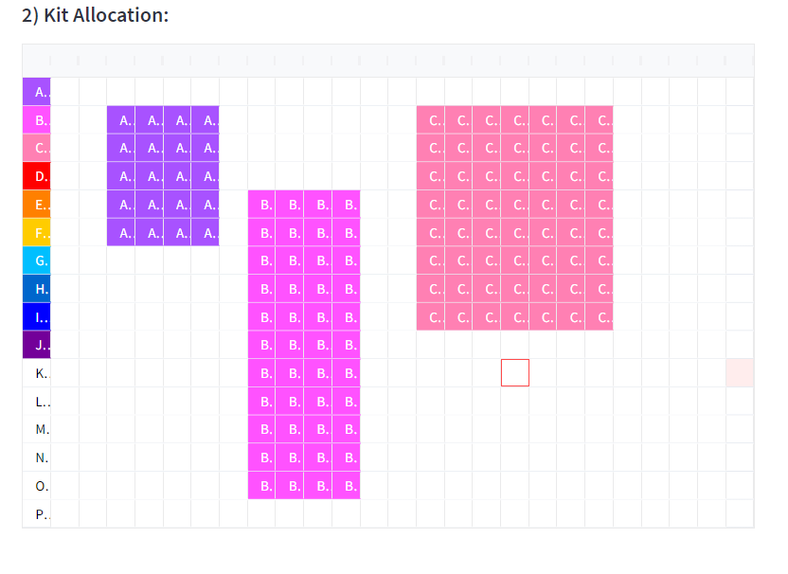for the above allocation, the resulting import file for QS:

Continues:

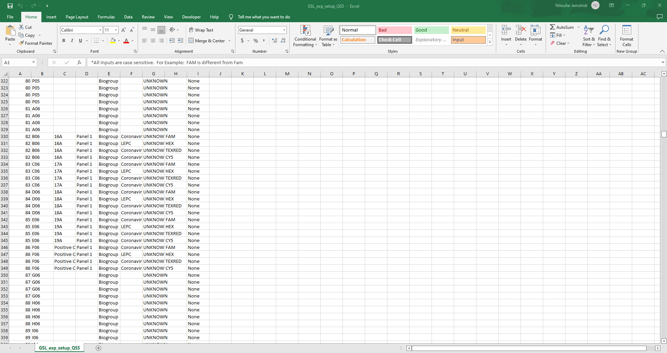

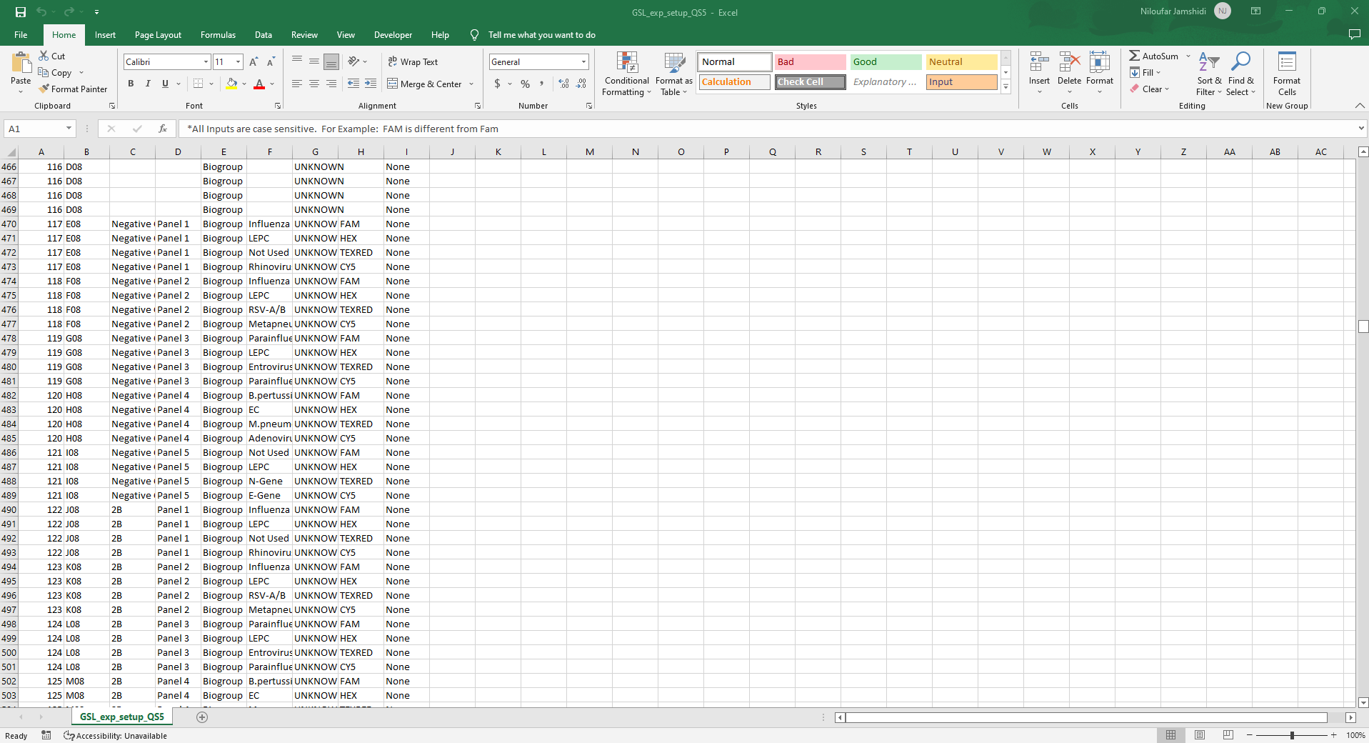Continues:

Continues:

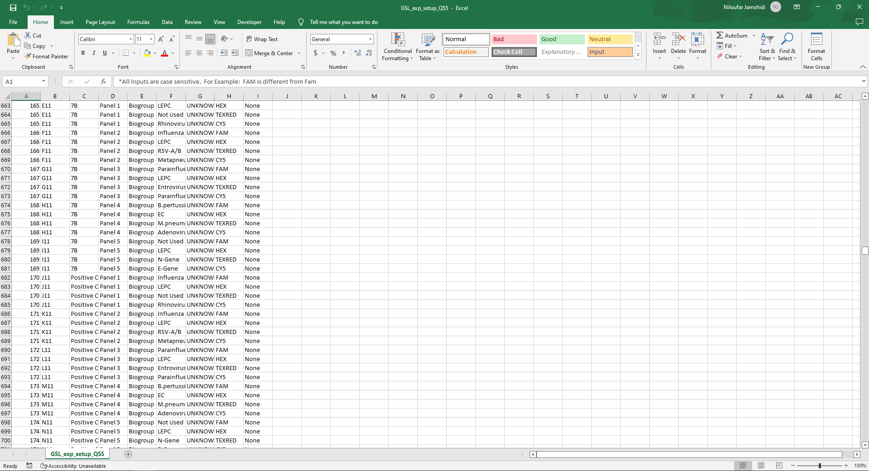

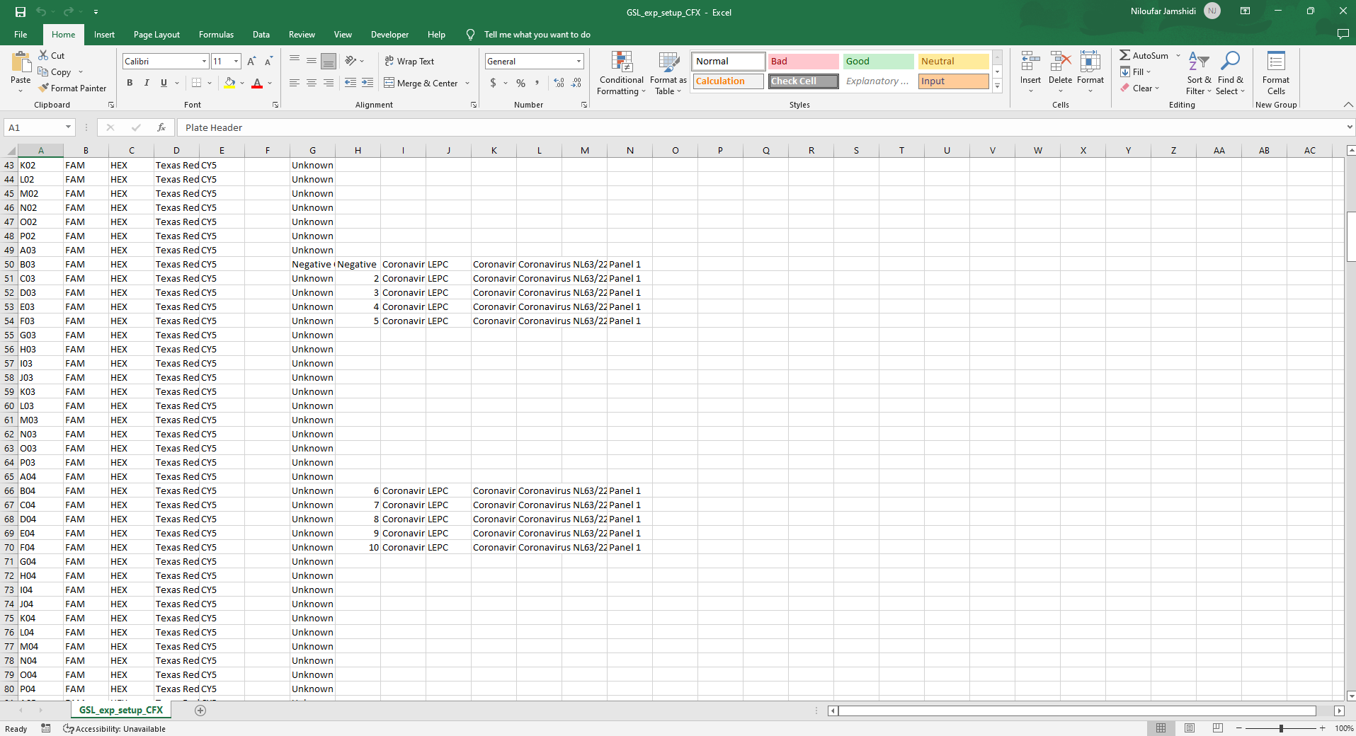For CFX with the same layout:

